189Z Homework 4: Ethan Greenberg

# FF Neural Network

## Learning Rates

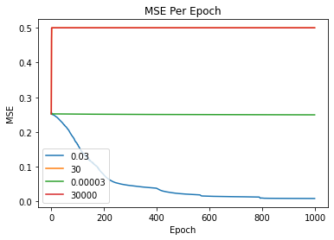

## Hidden Layer Size

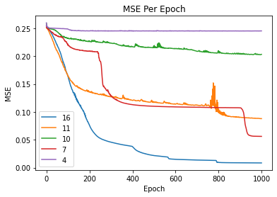

## Two Hidden Layers

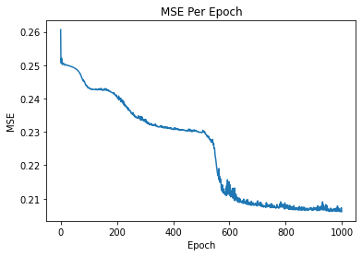

# RNN

